**[16] Design Turing Machine Simulation Which Accepts String AnB2n**

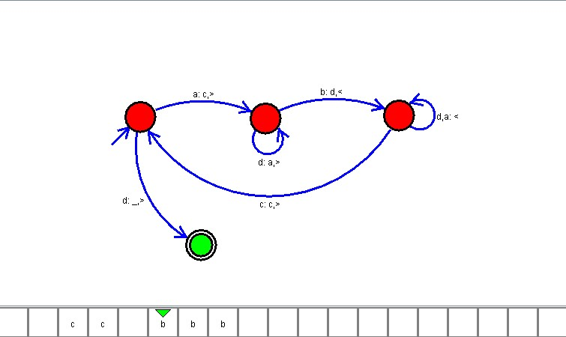

**Result**

The TM is designed to compute the given strings as input using Simulator to accept the string given as input